FARM MANAGEMENT SYSTEM

User Story
Within the Farm Management System (FMS), users such as farmers, farm managers, and system administrators need a centralized Salesforce-based platform for recording and managing information about farms, crops, farmers, and buyers, so that all agricultural data stays secure and systematically organized. Farm details, crop production records, and buyer transactions should be easy to enter and update through a friendly interface, with validation rules in place to block incorrect entries. The system should also deliver real-time reports and interactive dashboards, allowing users to assess farm productivity, track sales, and take informed decisions. In addition, role-based access and secure storage should protect sensitive information while still permitting smooth collaboration. Ultimately, the system aims to cut down manual paperwork, reduce errors, boost efficiency, and enable data-driven farm management.

1. INTRODUCTION

1.1 Project Overview
The Farm Management System (FMS) is a Salesforce-based application built to digitize and streamline agricultural operations. It handles data relating to farms, crops, farmers, and buyers, and offers real-time insights through reports and dashboards. This helps farmers and managers keep track of agricultural activities efficiently and make well-informed decisions.

1.2 Purpose
The project's core objectives are to:
- Bring agricultural data management into the digital space
- Raise data accuracy and make it more accessible
- Automate the handling of records
- Enable real-time monitoring
- Support farming decisions backed by data
- Improve productivity and transparency

2. IDEATION PHASE

2.1 Problem Statement (Customer Problem Statement Template)

PS | I am (Customer) | I’m trying to | But | Because | Which makes me feel
PS-1 | Farmer | Maintain farm and crop records | Data is often incomplete or incorrect | Records are kept manually in registers | Frustrated and confused
PS-2 | Farm Manager | Monitor farm productivity and sales | Reports are delayed and inaccurate | Data is scattered across files and sheets | Stressed and inefficient
PS-3 | Buyer | Access crop availability and pricing | Information is not updated regularly | There is no centralized digital system | Uncertain and dissatisfied
PS-4 | System Admin | Manage user access and system security | Unauthorized access may occur | Access control is handled manually | Concerned and insecure
PS-5 | System Admin | Track data changes and audit records | Change history is incomplete | Auditing is done manually | Exposed and worried
PS-6 | Buyer | Track order and delivery status | Status updates are unclear | Updates are shared manually | Anxious and dissatisfied

2.2 Empathy Map Canvas
Target Users:
- Farmers
- Farm Managers
- Buyers
- System Administrators
Empathy Analysis
- Think & Feel: Need accurate and timely farm data
- Hear: Feedback from agricultural officers
- See: Registers, paper files, spreadsheets
- Say & Do: Enter records manually
- Pain: Data loss, errors, delays
- Gain: Automation, fast reporting

2.3 Brainstorming
Ideas generated:
- Manual farm records
- Excel-based management
- Salesforce-based FMS
- Standalone desktop farm software
- Web-based custom farm portal
- Mobile-first farm management app
- Cloud-based CRM adaptation (Salesforce)
Chosen idea: Salesforce-based Farm Management System.

3. REQUIREMENT ANALYSIS PHASE

3.1 Customer Journey Map
Stages:
- Login
- Access Farm Management App
- Enter Farm and Crop Data
- Register Farmers and Buyers
- Generate Reports
- Analyze Results
- Decision Making

3.2 Solution Requirements
Functional Requirements
FR No | Requirement
FR-1 | User Authentication
FR-2 | Farm, Crop, Farmer, Buyer Management
FR-3 | Data Entry and Validation
FR-4 | Relationship Mapping
FR-5 | Report Generation
FR-6 | Dashboard Visualization
FR-7 | User Role Management
FR-8 | Notification and Alerts
FR-9 | Data Backup and Recovery
FR-10 | Audit Trail and History Tracking
Non-Functional Requirements
NFR | Description | Example
Usability | Easy interface | Simple Lightning UI
Security | Data protection | Profiles & roles
Reliability | No data loss | Cloud backup
Performance | Fast access | Reports in <3 sec
Availability | 24/7 access | Cloud hosting
Scalability | Handles growth | More farms/users
Maintainability | Easy to update and modify | Declarative configuration
Compliance | Meets agricultural data standards | GDPR / local data laws

3.3 Data Flow Diagram
Data Flow:
User → Salesforce UI → Custom Objects (Farm, Crop, Farmer, Buyer) → Validation Rules → Relationships → Reports → Dashboards

3.4 Technology Stack
Layer | Technology
Frontend | Salesforce Lightning UI
Backend | Salesforce Platform
Database | Salesforce Cloud
Automation | Validation Rules
Analytics | Reports & Dashboards

4. PROJECT DESIGN PHASE

4.1 Problem–Solution Fit
The Farm Management System addresses the shortcomings of conventional record-keeping by offering a unified, cloud-based alternative. Each aspect of the solution is outlined below.

4.2 Proposed Solution

Parameter | Description
Problem | Farm, crop, farmer, and buyer records are currently maintained by hand. This approach is prone to errors, vulnerable to data loss, and causes delays in accessing vital information.
Solution | A Salesforce-powered Farm Management System that centralizes all agricultural data and automates routine record-handling tasks.
Innovation | The system introduces automated validation at the point of data entry, secure cloud storage, and real-time reporting dashboards — features that are absent from manual or spreadsheet-based methods..
Impact | Farmers and managers gain access to accurate, up-to-date information. Reporting becomes faster, and decision-making improves as a result.
Business Model | The platform operates as a digital farm management and agricultural data services offering.
Scalability | Built on cloud infrastructure, the system can accommodate additional farms, users, and regions without significant rework.

4.3 Solution Architecture
Architecture Layers
- Presentation Layer – Salesforce Lightning UI
- Application Layer – Validation Rules, Relationships
- Data Layer – Custom Objects
- Analytics Layer – Reports and Dashboards

5. PROJECT PLANNING & SCHEDULING

5.1 Project Planning
- Created Salesforce Developer Org
- Developed custom objects
- Configured tabs and Lightning App
- Created fields and relationships
- Designed profiles and roles
- Created users and sharing rules
- Developed reports and dashboards
- Conducted testing and reviews

Product Backlog, Sprint Schedule, and Estimation
Sprint | Functional Requirement (Epic) | User Story Number | User Story / Task | Story Points | Priority | Team Members
Sprint-1 | Salesforce Account Creation | USN-1 | I want to understand the overall system story so that I know the scope of the Farm Management System. | 3 | High | 1
Sprint-1 | Salesforce Account Creation | USN-2 | I want to create a Salesforce Developer Org so that I can begin building the application. | 8 | High | 1
Sprint-1 | Salesforce Account Creation | USN-3 | As a system administrator, I want to activate my Salesforce account so that I can log in and access the platform. | 3 | High | 1
Sprint-2 | Objects | USN-4 | As an admin, I want to create a custom object for Farm so that farm data can be stored systematically. | 1 | High | 2
Sprint-2 | Objects | USN-5 | As an admin, I want to create a custom object for Crop so that crop data can be recorded. | 1 | High | 2
Sprint-2 | Objects | USN-6 | As an admin, I want to create a custom object for Farmer so that farmer details can be maintained. | 1 | High | 2
Sprint-2 | Objects | USN-7 | As an admin, I want to create a custom object for Buyer so that buyer information can be tracked. | 1 | High | 2
Sprint-3 | Tabs | USN-8 | As a staff member, I want a Farm tab so that I can quickly access farm records. | 1 | High | 3
Sprint-3 | Tabs | USN-9 | As a staff member, I want a Crop tab so that I can quickly access crop records. | 1 | High | 3
Sprint-3 | Tabs | USN-10 | As a staff member, I want a Farmer tab so that I can quickly access farmer records. | 1 | High | 3
Sprint-3 | Tabs | USN-11 | As a staff member, I want a Buyer tab so that I can quickly access buyer records. | 1 | High | 3
Sprint-4 | Lightning App | USN-12 | As a staff member, I want a Lightning App containing all farm modules so that I can navigate and perform daily operations easily. | 5 | High | 4
Sprint-5 | Fields and Relationship | USN-13 | As an admin, I want to create fields for the Farm object so that complete farm details can be captured. | 1 | High | 4
Sprint-5 | Fields and Relationship | USN-14 | As an admin, I want to create fields for the Crop object so that complete crop details can be captured. | 1 | High | 4
Sprint-5 | Fields and Relationship | USN-15 | As an admin, I want to create fields for the Farmer object so that complete farmer details can be captured. | 1 | High | 4
Sprint-5 | Fields and Relationship | USN-16 | As an admin, I want to create fields for the Buyer object so that complete buyer details can be captured. | 1 | High | 4
Sprint-6 | Profile | USN-17 | As an administrator, I want to create a custom profile so that user permissions can be controlled. | 1 | High | 5
Sprint-6 | Profile | USN-18 | As an administrator, I want to create a second custom profile so that different user groups can have distinct access. | 1 | High | 5
Sprint-6 | Role | USN-19 | As an administrator, I want to create a role so that the reporting hierarchy is defined. | 1 | High | 5
Sprint-6 | Users | USN-20 | As an administrator, I want to create a user so that team members can log in and use the system. | 1 | High | 3
Sprint-6 | Users | USN-21 | As an administrator, I want to create a user for the Sales Department so that sales staff can access relevant records. | 1 | High | 5
Sprint-7 | Sharing Rules | USN-22 | As an administrator, I want to create a sharing rule so that records are shared based on conditions. | 1 | High | 1
Sprint-7 | Sharing Rules | USN-23 | As an administrator, I want to share Buyer records with the Sales department so that they have Read/Write access. | 1 | High | 1
Sprint-7 | User Adoption | USN-24 | As a staff member, I want to create a Farmer record so that I can verify the system works end-to-end. | 1 | High | 2
Sprint-8 | Reports | USN-25 | As a farm manager, I want to create a report so that I can view farmer and farm data together. | 1 | High | 2
Sprint-8 | Reports | USN-26 | As a farm manager, I want to create a report using Crops and Buyers so that I can analyse related data. | 1 | High | 4
Sprint-8 | Dashboard | USN-27 | As a farm manager, I want to create a dashboard so that I can monitor performance visually. | 2 | Medium | 3
Sprint-8 | View Report and Dashboard | USN-28 | As a farm manager, I want to view the report so that I can review the records. | 1 | Medium | 1
Sprint-8 | View Report and Dashboard | USN-29 | As a farm manager, I want to view the dashboard so that I can review summarised data. | 1 | Medium | 1

Project Tracker, Velocity & Burndown Chart
Sprint | Total Story Points | Duration | Sprint Start Date | Sprint End Date (Planned) | Story Points Completed (as on Planned End Date) | Sprint Release Date (Actual)
Sprint-1 | 14 | 1 Day | 16 Sep 2026 | 16 Sep 2026 | 14 | 16 Sep 2026
Sprint-2 | 4 | 1 Day | 17 Sep 2026 | 17 Sep 2026 | 4 | 17 Sep 2026
Sprint-3 | 4 | 1 Day | 18 Sep 2026 | 18 Sep 2026 | 4 | 18 Sep 2026
Sprint-4 | 5 | 1 Day | 19 Sep 2026 | 19 Sep 2026 | 5 | 19 Sep 2026
Sprint-5 | 4 | 1 Day | 20 Sep 2026 | 20 Sep 2026 | 4 | 20 Sep 2026
Sprint-6 | 5 | 1 Day | 21 Sep 2026 | 21 Sep 2026 | 5 | 21 Sep 2026
Sprint-7 | 3 | 1 Day | 22 Sep 2026 | 22 Sep 2026 | 3 | 22 Sep 2026
Sprint-8 | 6 | 2 Days | 23 Sep 2026 | 24 Sep 2026

6. PROJECT DEVELOPMENT PHASE

Project Description
Built on Salesforce, the Farm Management System (FMS) is a complete solution intended to digitize and streamline agricultural operations. It enables farmers, farm managers, and stakeholders to manage data concerning crops, farms, farmers, and buyers, while surfacing actionable insight through reports and dashboards.

Milestone 1 – Salesforce

What Is Salesforce?
Salesforce is a customer success platform built to help you sell, service, market, analyze, and connect with your customers. It provides everything required to run your business from anywhere. With standard products and features, you can manage relationships with prospects and customers, collaborate and engage with employees and partners, and keep your data securely in the cloud.

Activity 1: Creating a Salesforce Developer Org
A Developer org comes with all the features and licenses needed to get started with Salesforce.
- Navigate to https://salesforce.com/products/free-trial/developer
- Fill in the details — First name, last name, Email, Role, Company, Country/Region, Postal code, and a Username that must be unique.
- Click "sign me up." After a few minutes you will receive a mail from Salesforce; use the verify account link to set your new password.
- Click save.
- Navigate to login.salesforce.com
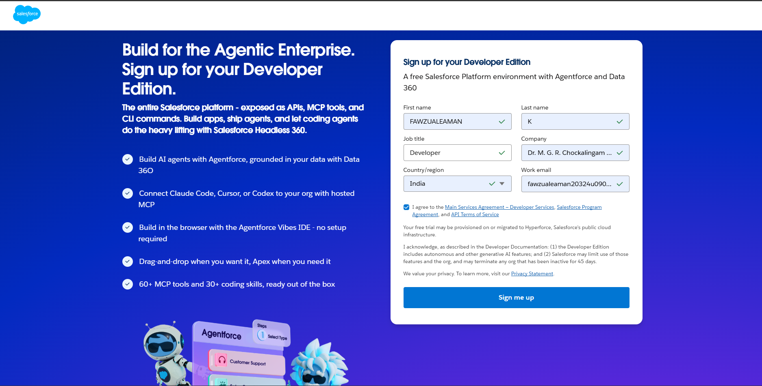
- Log in with username and password to enter the Salesforce org. The homepage will appear as shown below.
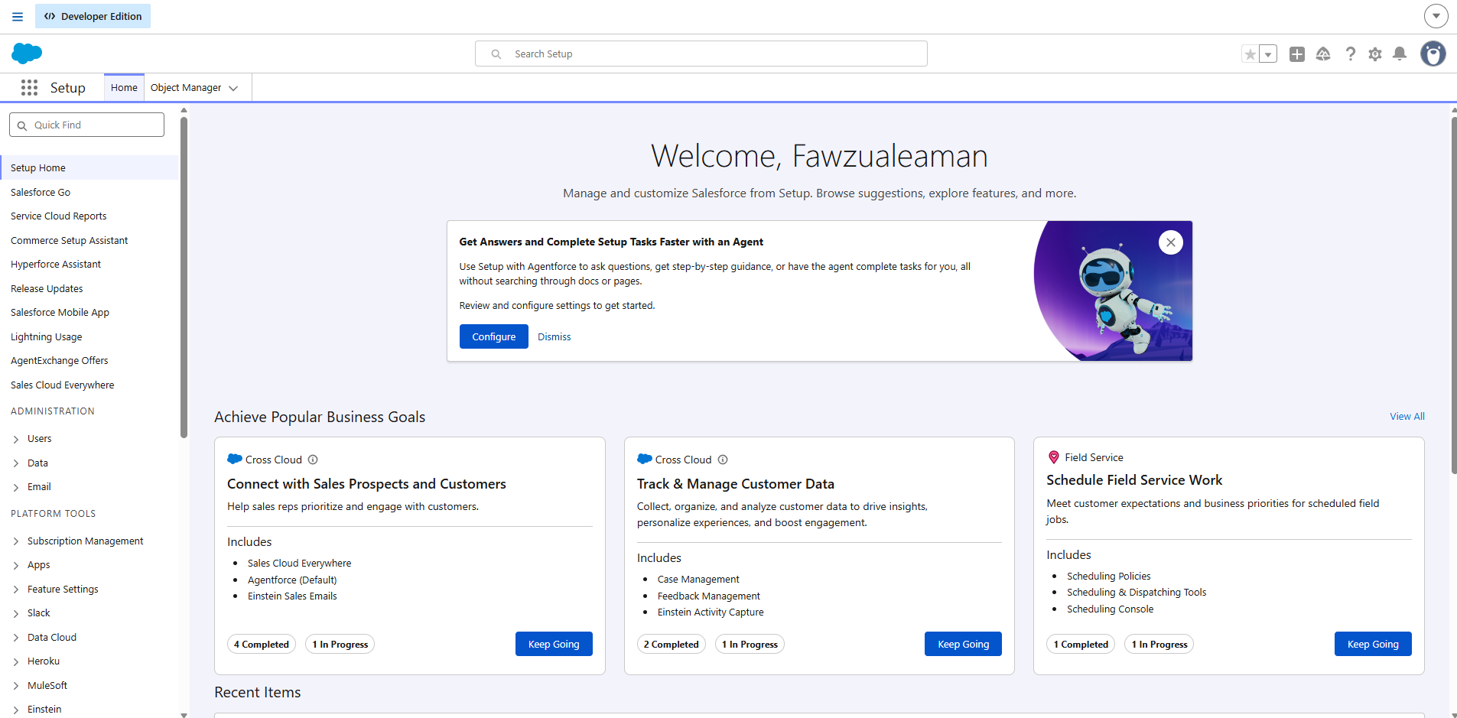

Milestone 2 – Object

What is an object?
Salesforce objects are database tables that let you store data specific to an organization. Each object consists of fields (columns) and records (rows).
Four custom objects are used in this application:
- Farm
- Crop
- Farmer
- Buyer

Activity 1: Create a custom object for Farm
To create a custom object, follow these steps:
- From Setup, click Object Manager.
- Click Create, then select Custom Object.
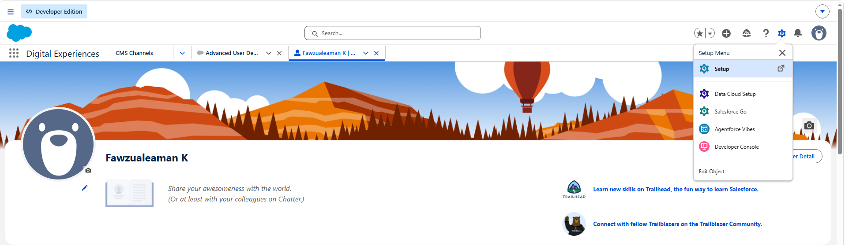
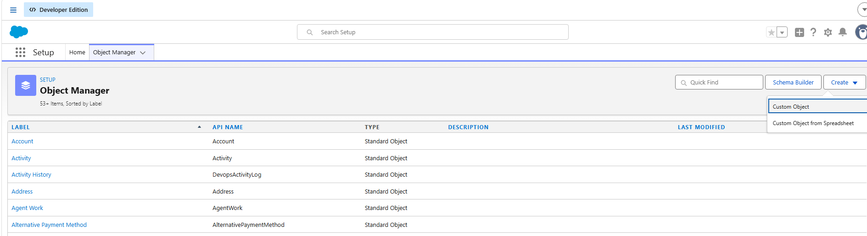
- Enter the label as "Farm".
- Enter the plural label as "Farms".
- Record name: "Farm Name".
- Choose the data type "Text".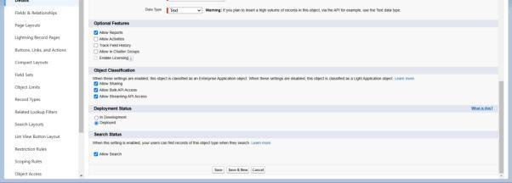
- Under Optional Features, tick Allow Reports and Track Field History.
- Under Deployment Status, make sure Deployed is selected.
- Under Search Status, select Allow Search.
- Under Object Creation Options, tick Add Notes and Attachments related list to default page layout.
- Leave the remaining settings unchanged and click Save.

Activity 2: Creation of Crop object
- Click the gear icon, then choose Setup.
- Click the Object Manager tab, located next to the Home tab.
- On the extreme right you will find a Create dropdown; click it and choose Custom Object.
a. On the Custom Object Definition page, configure the object as follows:
b. Label: Crop
c. Plural Label: Crops
d. Record Name: Crop Name
e. Choose the data type "Text".
f. Tick the Allow Reports checkbox.
g. Tick the Allow Search checkbox.
h. Under Object Creation Options, tick Add Notes and Attachments related list to default page layout.
i. Click Save.

Activity 3: Creation of Farmer object
- Click the gear icon, then choose Setup.
- Click the Object Manager tab, located next to the Home tab.
- On the extreme right you will find a Create dropdown; click it and choose Custom Object.
a. On the Custom Object Definition page, configure the object as follows:
b. Label: Farmer
c. Plural Label: Farmers
d. Record Name: Farmer Name
e. Choose the data type "Text".
f. Tick the Allow Reports checkbox.
g. Tick the Allow Search checkbox.
h. Under Object Creation Options, tick Add Notes and Attachments related list to default page layout.
i. Click Save.

Activity 4: Creation of Buyer object
- Click the gear icon, then choose Setup.
- Click the Object Manager tab, located next to the Home tab.
- On the extreme right you will find a Create dropdown; click it and choose Custom Object.
a. On the Custom Object Definition page, configure the object as follows:
b. Label: Buyer
c. Plural Label: Buyers
d. Record Name: Buyer Name
e. Choose the data type "Text".
f. Tick the Allow Reports checkbox.
g. Tick the Allow Search checkbox.
h. Under Object Creation Options, tick Add Notes and Attachments related list to default page layout.
i. Click Save.

Milestone 3 – Tab

Tab
Tabs in Salesforce let users view information at a glance. They display object data and other web content within the application.

Activity 1: Creation of Farm tab
Now create a custom tab.
- Click the Home tab, type "Tabs" in Quick Find, and select Tabs.
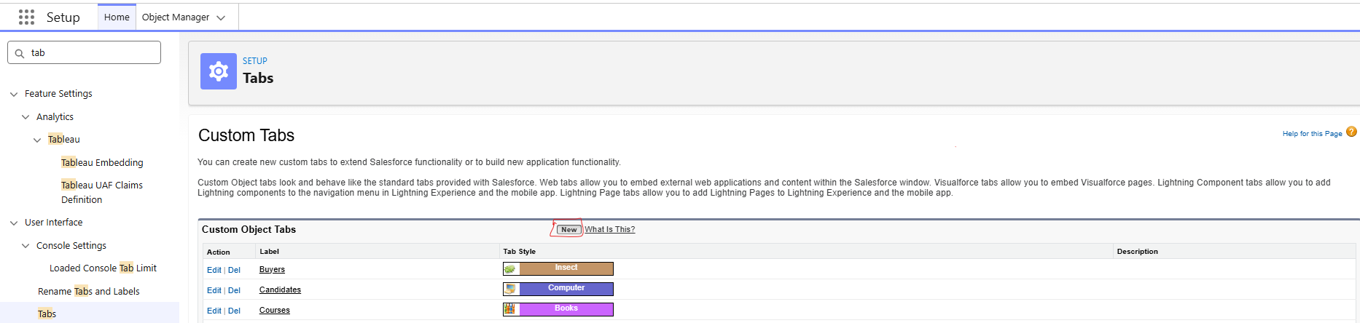
- Under Custom Object Tabs, click New.
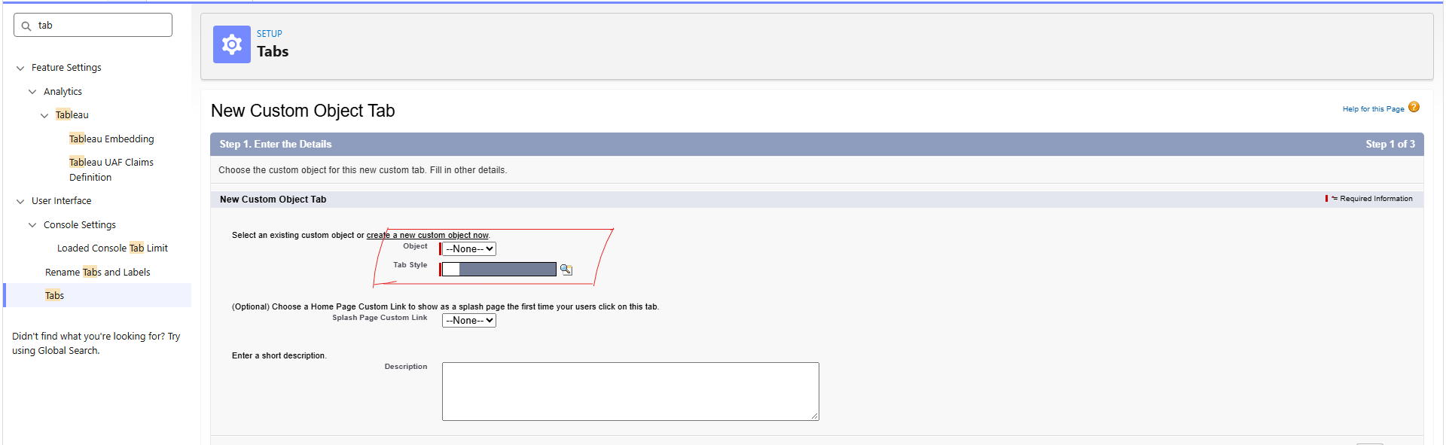
- For Object, select Farm.
- For Tab Style, pick any icon.
- Keep all defaults unchanged. Click Next, Next, and Save.

Activity 2: Creation of Crop tab
Now create a custom tab.
- Click the Home tab, type "Tabs" in Quick Find, and select Tabs.
- Under Custom Object Tabs, click New.
- For Object, select Crop.
- For Tab Style, pick any icon.
- Keep all defaults unchanged. Click Next, Next, and Save.

Activity 3: Creation of Farmer tab
Now create a custom tab.
- Click the Home tab, type "Tabs" in Quick Find, and select Tabs.
- Under Custom Object Tabs, click New.
- For Object, select Farmer.
- For Tab Style, pick any icon.
- Keep all defaults unchanged. Click Next, Next, and Save.

Activity 4: Creation of Buyer tab
Now create a custom tab.
- Click the Home tab, type "Tabs" in Quick Find, and select Tabs.
- Under Custom Object Tabs, click New.
- For Object, select Buyer.
- For Tab Style, pick any icon.
- Keep all defaults unchanged. Click Next, Next, and Save.

Milestone 4 – Lightning App
What is an App?
In Salesforce, an app is a group of tabs that work together as a single unit. It carries a name, a logo, and a specific set of tabs. The simplest app typically has only two tabs.

Activity 1: Create the Farm Management System app
- From Setup, type "App Manager" in Quick Find and select App Manager.
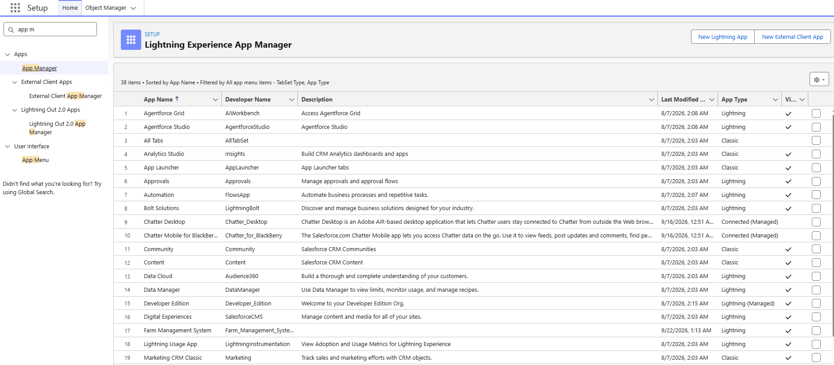
- Click New Lightning App. Enter "Farm Management System" as the App Name, then click Next.
- Under App Options, leave the default selections and click Next.
- Under Utility Items, leave as is and click Next.
- From Available Items, select Farm, Crop, Farmer, Buyer, Reports, and Dashboards, and move them to Selected Items. Click Next.
- From Available Profiles, select System Administrator and move it to Selected Profiles. Click Save & Finish.
- To verify your changes, click the App Launcher, type "Farm Management System", and select the Job Application app.
Note:
- App Launcher – Displays available apps.
- App Name – Displays the currently selected app.
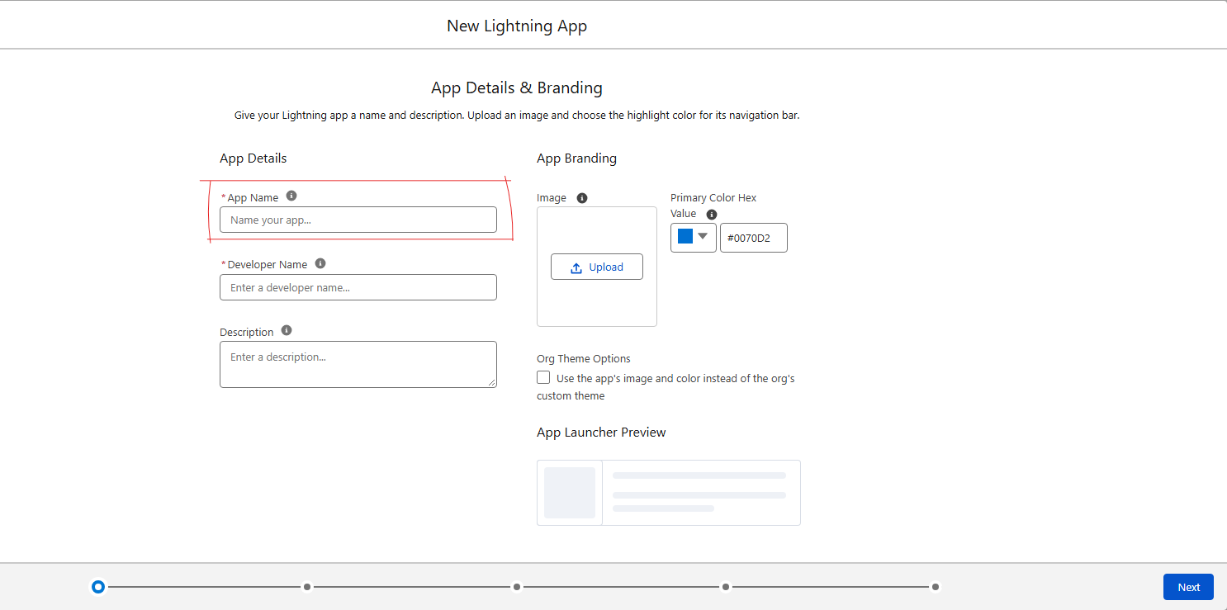
- Navigation menu – Displays the tabs available inside the app.
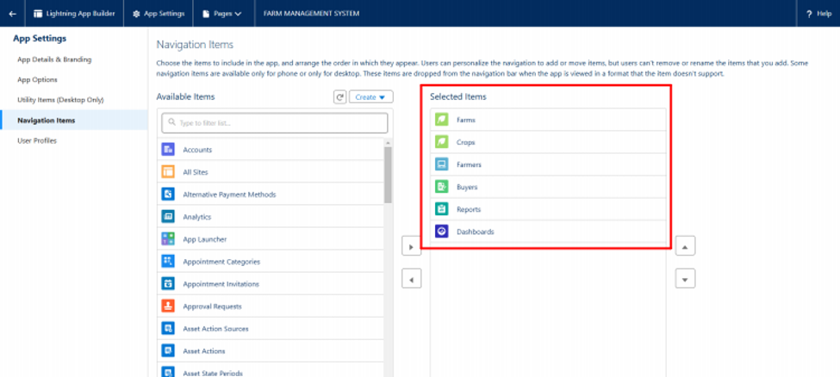

Milestone 5 – Fields and Relationship

What are fields?
Fields in Salesforce correspond to the columns in relational databases. A field stores data values required for a particular object within a record.

Activity 1: Creation of fields for the Farm object
- Click the gear icon and select Setup. Setup launches in a new tab.
- Click the Object Manager tab next to Home.
- Select Farm.
- Select Fields & Relationships from the left navigation, then click New.
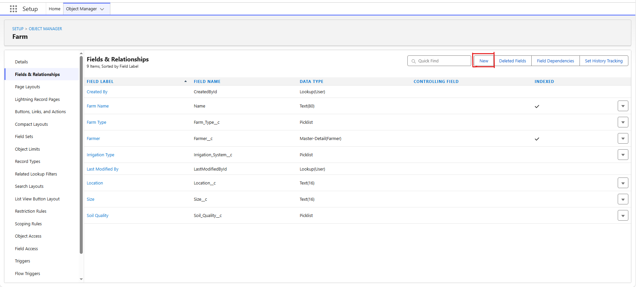
- Choose the data type as Picklist, then click Next.
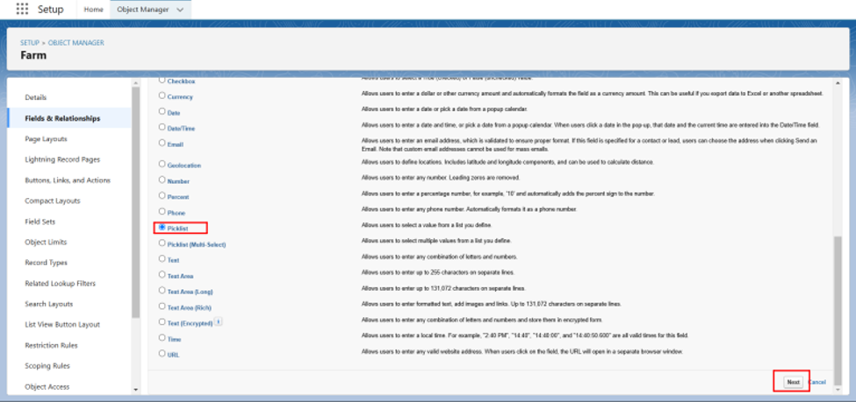
- Enter the Field Label (Farm Type) and enter values as (Crop, Livestock, Mixed).
- Click Next, Next, then Save.
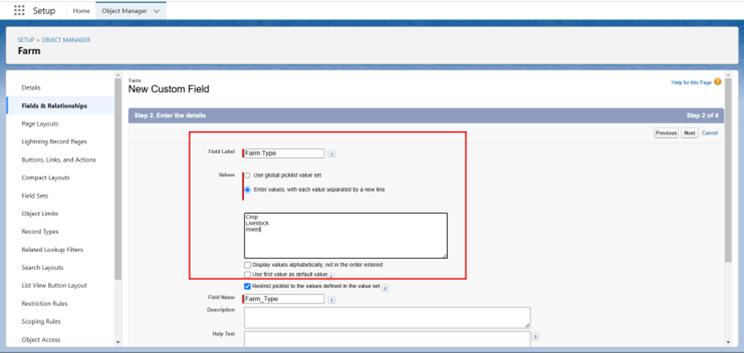
Now let's create the other fields by following steps 1 to 4 of Activity 1, choosing the data types carefully.
- Create another Picklist field. Enter the field label (Soil Quality) and values (Organic, Cover Crops, Composting).
- Create another Picklist field. Field Label (Irrigation Type), enter values (Sprinkler irrigation, Drip irrigation, localized irrigation).
- Choose the data type as Text and enter the field label (Location).
- Choose the data type as Text and enter the field label (Size).
- Create a Master-Detail relationship with the Farmer object.

Activity 2: Creation of fields for the Crop object
- Choose the data type as Text, enter the field label (Crop Name), Next, Save.
- Select the data type as Date, enter the field label (Planting Date), then Save.
- Again select the data type as Date, enter the field label (Harvest Date), Save.
- Create a Lookup relationship on the Crop object related to the Farm object.
- Select the data type as Currency, enter the field label (Actual Yield), Next, Save it.
- Select the data type as Number, enter the field label (Total Acres Harvested), enter Maximum Length (20), and Save.
- Now create a Formula field. For that, select the data type as Formula and click Next.
- Enter the field label (Expected Yield per Acre), select formula return type as Currency, click Next.
- Enter the formula: Actual Yield divided by Total Acres Harvested, then click Next and Save.
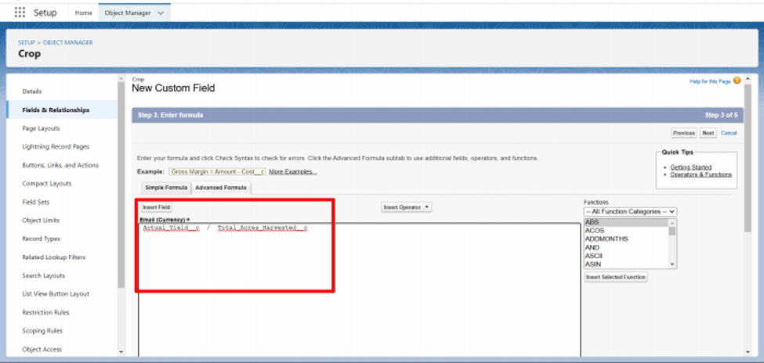

Activity 3: Creation of fields for the Farmer object
- Select the data type Phone, enter the field label (Contact Number), Next, Save.
- Select the data type Picklist, enter the field label (State), enter values (Telangana, Andhra Pradesh, Tamilnadu), Save.
- Choose the data type Picklist, enter the field label (District), enter values of districts, Next, Save.
- Again select the data type as Picklist, enter the field label (Village), enter values of villages, Next, Save.

Creation of field dependency
- Now create a field dependency for the District field. Open Object Manager, choose the Farmer object, select Fields & Relationships; on the right side you will find the Field Dependency option — select it.
- Click New, select the controlling field as State and the dependent field as District, then click Continue.
- Select the appropriate value in each column by double-clicking them.
- For example: Telangana – Yadadri Bhongir.
- Click Include Values. Do the same for Andhra Pradesh and Tamilnadu along with their cities.
- Click Preview, then test the dependency by selecting a different State and viewing the associated values available for that particular state.
- Click Close to close the preview window, then click Save.
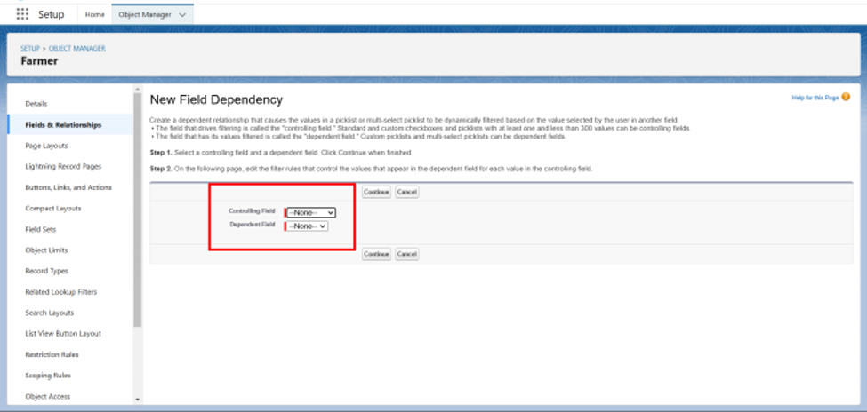

Activity 4: Creation of fields for the Buyer object
- Select the data type as Phone, enter the field label (Contact), Save.
- Select the data type as Email, enter the field label (Email), Next, Save.
- Select the data type Text Area, enter the field label (Address), Save it.
- Select the data type Picklist, field label (Buyer Type), enter values (Wholesale, Retail), click Save.

Milestone 6 – Profile

What is a profile?
A profile is a group or collection of settings and permissions that define what a user can do in Salesforce. A profile governs object permissions, field permissions, user permissions, tab settings, app settings, Apex class access, Visualforce page access, page layouts, record types, login hours, and login IP ranges.
A single profile can be assigned to many users, but a user can hold only one profile at a time.

Activity 1: Create a custom profile
- From Setup, type "profiles" in the Quick Find box.
- Select Profiles (Standard User).
- Click Clone.
- For Profile, enter Sales Department.
- Click Save.

Activity 2: Create a custom profile-2
Create a profile named "Farm Manager".
- From Setup, type "profiles" in the Quick Find box.
- Select Profiles (Standard User).
- Click Clone.

Milestone 7 – Role
In Salesforce, roles determine which users can access certain data and functions within the system. They also define the reporting hierarchy inside an organization. Users holding higher roles get greater data access and more control over the system.

Activity 1: Creation of role
- From the Quick Find box, search for "role" and click the Roles option.
- Select the Set Up Roles option.
- Below CEO, click Add Role, enter the label name as "Farm Manager" — the role name will be populated automatically — then click Save.

Milestone 8 – User

What is a user?
A user is anyone who logs into Salesforce. Users are employees at your company — such as sales reps, managers, and IT specialists — who need access to the company's records. Every user in Salesforce has a user account. The user account identifies the user, and the account settings determine which features and records the user can access.
NOTE: A Salesforce license can only be used by 2 users at a time in a Dev Org. So, if you don't find a Salesforce license available, deactivate a user who currently holds one, or change that user's license type from Salesforce to another type.

Activity 1: To create a user
- From Setup, type "Users" in the Quick Find box, then select Users.
- Click New User.
- Enter the First name as Farm and the last name as Manager.
- Enter the user's name, email address, and a unique username in the form of an email address. By default, the username is the same as the email address.
- Select the role Farm Manager.
- Select the user License as Standard Platform User.
- Select the profile (Farm Manager).
- Click Save.

Activity 2:
Create a user with the username "Sales Department" and assign that user the Sales Manager profile. Follow the steps from the Activity above.

Milestone 9 – Sharing Rules

What are Sharing Rules?
Sharing rules let users share records based on conditions. They are essentially created for objects whose organization-wide defaults (OWD) are set to public read-only or private, because sharing rules can only extend access — they cannot restrict it.
Types of sharing rules:
- Owner-based Sharing Rules
- Criteria-based Sharing Rules

Activity 1: Create a sharing rule
- Go to Sharing Settings, which can be found under the Quick Find section.
- Scroll down to find the object where a sharing rule needs to be added, then click New to create a new sharing rule.
- Add the label of the sharing rule you want to create.
- Select your rule type based on the criteria.
- Select the field "can join immediately" — check the field from the Crop object.
- Select Crop as equal and the value as True.
- In the "select the users to share with" section, select roles and, within that, select Farm Manager.
- In the "select the level of access for the users" section, grant Read/Write access.
- Save the rule.
Activity 2: Create a sharing rule to share the records of Buyer with the Sales department with Read/Write access. Follow the steps from the Activity above.

Milestone 10 – User Adoption

Activity 1: Create a Record (Farmer)
- Click App Launcher on the left side of the screen.
- Search for Farm Management and click it.
- Click the Farmer tab.
- Click New, fill in the details, and Save.

Milestone 11 – Reports

What are Reports?
A report is a list of records that meet the criteria you define. It is displayed in rows and columns and can be filtered, grouped, or shown as a graphical chart. Every report is stored in a folder. Folders can be public, hidden, or shared, and can be set to read-only or read/write.

Activity 1: Create a report
Create a report that displays the rating of the account and which has type and account name.
- Click App Launcher and search for Reports.
- Click New Report and select the category Farmer with Farms.
- In the Details section, select the option Start Report.
- In Outline, click Columns and select which fields you want to display in the report.
- Click Group and select which fields you want to group.
- Save the report by giving it the label name (Farmer with Farms), save it into a public folder, and save the report.

Activity 2:
Create a report using the objects Crops and Buyers. Follow the steps from the Activity above.

Milestone 12 – Dashboard
Dashboards deliver deeper insight than reports because they combine data from many reports and present a summarized result. Viewing many reports at once gives the flexibility of combining their results quickly. Summaries in dashboards also help in deciding on action plans faster. Dashboards can contain charts, graphs, and tabular data.

Activity 1: Create a Dashboard
- Click the Dashboard tab.
- Click New Dashboard.
- Name the dashboard "Farmers with Farms" and click Create.
- Click +Component.
- Select "Farmers with Farms" and click Select.
- Select the Gauge chart and click Add.
- Click Save and then Done.

Milestone 13 – View Report and Dashboard

Activity 1: Report
- Click App Launcher on the left side of the screen.
- Search for Farm Management System and click it.
- Click the Reports tab.
- Click "Farmers with Farms" and view the records.
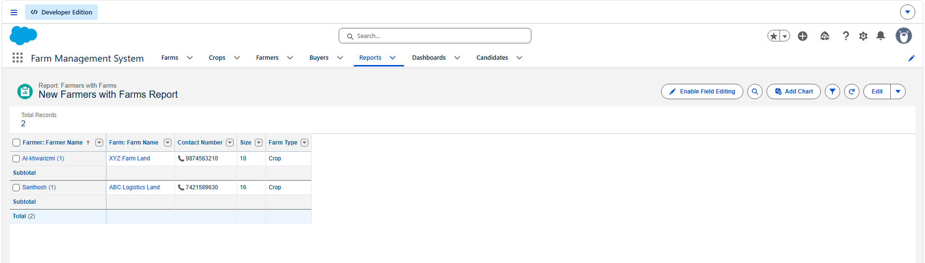

Activity 2: Dashboard
- Click App Launcher on the left side of the screen.
- Search for Farm Management System and click it.
- Click the Dashboard tab.
- Click "Farmers with Farms" and view the records.
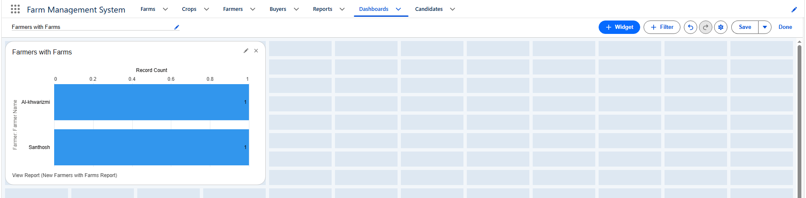

7. FUNCTIONAL & PERFORMANCE TESTING
During the testing phase, screenshots were captured from the Salesforce interface to verify system functionality. The following items were tested:
- Creation of Farm, Crop, Farmer, and Buyer records
- Validation of input fields
- Relationship and dependency checks
- Profile and role access testing
- Sharing rule verification
- Report and dashboard generation
Performance testing confirmed smooth system response and stability during multiple user operations.

8. ADVANTAGES & DISADVANTAGES
Advantages
- Centralized data system – All farm, crop, farmer, and buyer records are stored in one secure cloud location.
- Reduced paperwork – Eliminates manual registers and spreadsheets, saving time and storage space.
- Improved data accuracy – Validation rules prevent incorrect or incomplete entries at the point of entry.
- Better monitoring – Managers can track farm productivity and sales performance in real time.
- Real-time analytics – Reports and dashboards deliver instant insights for faster decision-making.
- Role-based security – Profiles, roles, and sharing rules protect sensitive data from unauthorized access.
- Scalability – Cloud infrastructure supports additional farms, users, and regions without major rework.
- Automation of routine tasks – Flows and validation rules reduce manual effort and human error.
Disadvantages
- Requires internet connection – The system cannot be used without an active internet connection.
- Salesforce license dependency – Continued use depends on Salesforce licensing and subscription costs.
- Limited offline access – Offline data entry and synchronization are not natively supported.
- Steep learning curve – New users, especially farmers, may need training to navigate the Salesforce interface.
- Customization limits – Complex requirements may require Apex/Visualforce coding beyond declarative tools.
- Data privacy concerns – Storing sensitive farmer and buyer data in the cloud raises privacy and compliance risks.
- Dependency on third-party platform – Downtime or policy changes at Salesforce can directly affect system availability.
- Initial setup cost and time – Configuring objects, fields, relationships, and security takes significant upfront effort.

9. CONCLUSION
The Farm Management System successfully digitizes agricultural data management using Salesforce. By centralizing information about farms, crops, farmers, and buyers, the system eliminates the inefficiencies of manual record-keeping and ensures data accuracy through validation rules, relationships, and role-based access control. Real-time reports and dashboards further enable farmers and managers to monitor productivity, track sales, and make informed decisions quickly. All planned milestones — from object creation and field configuration to profiles, roles, sharing rules, reports, and dashboards — were completed and tested for functionality and stability. Overall, the system reduces paperwork, minimizes errors, improves efficiency, and provides a scalable foundation for future enhancements such as mobile integration, AI-based crop prediction, and IoT connectivity.

10. FUTURE SCOPE
- Mobile application integration – Extend the FMS to Android and iOS so farmers can access and update records from the field.
- AI-based crop prediction – Use machine learning to forecast crop yields and recommend the best crops based on soil, season, and history.
- Weather data integration – Connect live weather APIs to provide forecasts, rainfall alerts, and irrigation guidance.
- IoT sensor connectivity – Link soil moisture, temperature, and humidity sensors for real-time, automated farm monitoring.
- Government scheme integration – Allow farmers to discover, apply for, and track agricultural subsidies and welfare schemes directly.
- Market price forecasting – Provide real-time mandi/market price trends and predictive pricing to help farmers sell at the best time.
- Multi-language and voice support – Add regional language interfaces and voice input so farmers with limited literacy can use the system easily.
- Blockchain-based traceability – Enable end-to-end traceability of crops from farm to buyer, ensuring transparency and fair pricing.

11. APPENDIX
- Source Code: Salesforce Configuration and Metadata
- Dataset: Farm, Crop, Farmer, and Buyer Records
- Tools Used: Salesforce Developer Org

THANK YOU!

